How to use the railway basemap?

First, download the excel files containing the IDs:

vasuti_vonalszakaszok_ID.xls
vasutallomasok_ID.xls

Using the ID-s build up your own database. If you want to have a map about Szamosvölgy railroad, then select the entities belonging to that railroad including the column of IDs..

Szamosvölgyi Vasút lines | Szakasz ID (Line ID)
Apahida–Dés | 16
Dés–Zsibó | 158
Dés–Betlen | 157
Betlen–Sajómagyaros | 80
Sajómagyaros–Beszterce | 587
Zsibó–Zilah | 832
Beszterce–Borgóbeszterce | 76

As the second step select railway stations of Szamosvölgy railroad from table vasútállomások_ID.xls

stations of Szamosvölgyi Vasút | Állomási ID (station ID) | to be visualized
Dés | 5073 | I
Alsózsuk | 5065
Válaszút-Bonchida | 5067
Nagyiklód | 5068
Dengeleg | 5069
Szamosújvár | 5070
Szamosújvárnémeti | 5071
Apahida | 792 | I
Borgóbeszterce | 5132 | I
Jád | 5127
Oroszborgó | 5128
Borgóprund | 5131
Sajómagyaros | 3254 | I
Somkerék | 5118
Bethlen | 5117 | I
Retteg | 5114
Csicsókeresztúr | 5115
Kapjon | 5075
Kackó | 5076
Galgó | 5078
Szamossósmező | 5079
Oroszmező | 5080
Nagyilonda | 5081
Büdöspataka | 5082 | I
Hosszúrév | 5083
Létka | 5084
Kocsoládfalva | 5085
Aranymező | 5086
Szurduk | 5087
Beszterce | 3259 | I
Szeretfalva | 3256
Zilah | 2652 | I
Zsibó | 5089 | I
Szilágypaptelek | 5104
Nyírsid | 5105

In the next step convert your xl file into csv. Open OpenOffice programot read the xls files the click on Save as. Pop-up window should be saved as below:

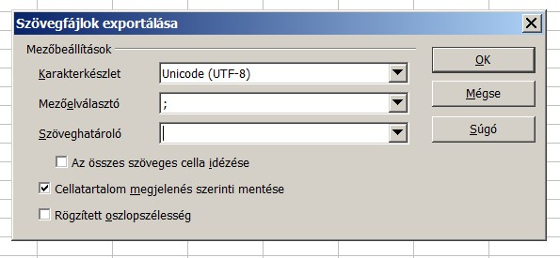

This file will be opened by QGIS (which is downloadable free of charge from the internet).

How to use QGIS to open and visualize data?

After installing QGIS on your PC please also copy the following files into your computer:

vasutallomas.dbf
vasutallomas.shp
vasutallomas.shx
vasutvonal.dbf
vasutvonal.shp
vasutvonal.shx

After opening QGIS read the following two files:

vasutvonal.shp
vasutallomas.shp

To open the two files watch the following video:

01_vektoros_retegek_beolvasasa.mp4

The next step is to open the csv files converted from the xls. For this watch the next video:

02_szoveges_retegek_beolvasa.mp4

Then we have to join the data to the vector layers. Data (csv) on railway stations should be attached to the vector file about the railway stations, while the csv file containing information on railway lines should be attached to the vector file about railway lines. For these step watch the videos below:

03_osszekapcsolas_vasutvonalak.mp4
04_osszekapcsolas_vasutallomasok.mp4

Then we read in the names of raiway stations to be visualized:

05_vasutallomasok_neve.mp4

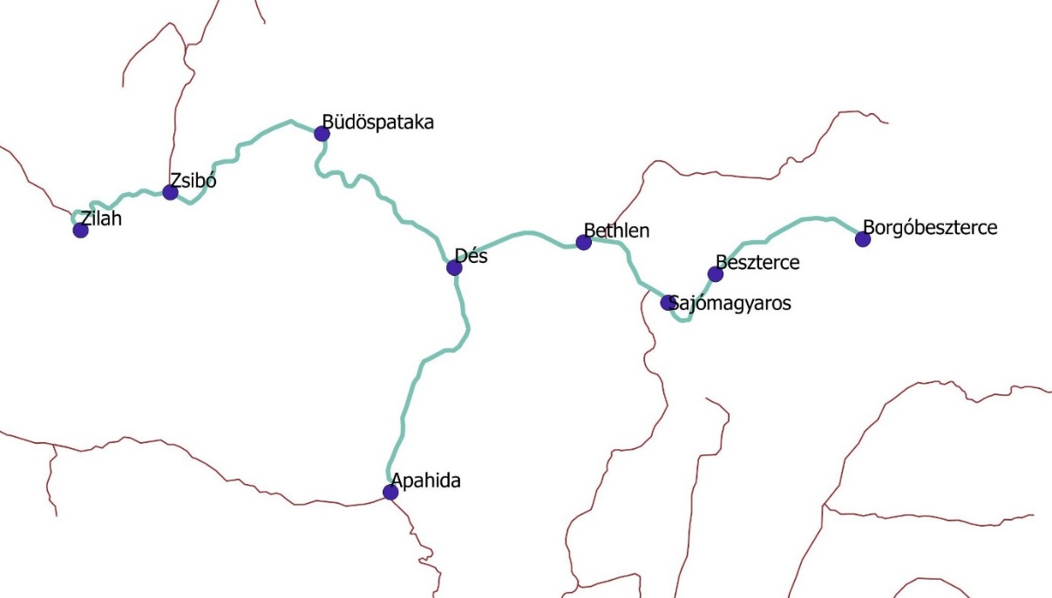
The map after the fifth step

And finally to export our result (maps) watch the following video:

06_terkep_exportalasa.mp4

Should you have any questions please contact:
Frisnyak.Zsuzsa@btk.mta.hu.

